

Alandi (D), Pune

Affiliated to



Savitribai Phule Pune University

**A**

**PROJECT REPORT**

**ON**

**“Sentinel Task Management System”**

# BY

1. Sangram Sunil Dhembare (TI3301)
2. Riya Sunil Daphal (TI3311)

Under the guidance of

# Prof. Pallavi Gholap

In Partial fulfillment of

**T.Y.B.Sc(CS)**

**Academic Year 2024-25**



# CERTIFICATE

Exam Seat No:

This is to certify that, the project report entitled “**Sentinel Task Management System**’’ which is submitted by **Sangram Dhembare** and **Riya Daphal**, ROLL NO: **(TI3301) & (TI3311),** Division I3 students of MAEER’s MIT Arts, Commerce and Science College, Alandi(D), Pune-412105 in partial fulfillment of T.Y.B.Sc. (Computer Science) Project Work in academic year 2024-25. They have satisfactorily completed the project work under our guidance and supervision. We wish our best wishes for your future endeavor.

|  |  |
| --- | --- |
|  | Dr. Sangita Birajdar |
| Project Guide | HOD (Sci and Comp. Sci) |
| Internal Examiner | External Examiner |

# ACKNOWLEDGEMENT

I take this opportunity to express my sincere gratitude to everyone who has directly or indirectly helped me in completing the project successfully. I owe profound intellectual debt to

**Ms. Pallavi Gholap** who is a guiding source of encouragement and helped me through-out the course of my project. I am also thankful to **Director. Dr. B. B. Waphare**, Principal **MIT Arts Commerce and Science College Alandi(D)**, **Pune-412105** and also to **Dr. Sangita Birajdar**, HOD, Science and Comp. Science for providing me with this opportunity.

**Sangram Dhembare**

**TYBSC(CS)-I3**

**Riya Daphal**

**TYBSC(CS)-I3**

# INDEX

|  |  |  |
| --- | --- | --- |
| **Sr. No.** | **Chapter** | **Page No** |
| **1** | **INTRODUCTION** | **5** |
| 1.1 Introduction | 5 |
| 1.2 Problem statement | 5 |
| 1.3 Objectives and goals | 5 |
| 1.4 Scope of the System | 5 |
| 1.5 Existing System and Need of the System | 5 |
| **2** | **PROPOSED SYSTEM** | **6** |
| 2.1 Proposed System | 6 |
| 2.2 Advantages and Disadvantages | 6 |
| 2.3 Feasibility Study | 6 |
| 2.4 System Requirements (software and Hardware Specification) | 7 |
| **3** | **DATA DICITIONARY AND RELATIONAL DATABASE DIAGRAM** | **8** |
| **4** | **SYSTEM MODELING** | 10 |
| 4.1 ER Diagram | 10 |
| 4.2 Class Diagram | 11 |
| 4.3 Use Case Diagram | 12 |
| 4.4 Activity Diagram | 13 |
| 4.5 Sequence Diagram | 14 |
| 4.5 Deployment Diagram | 15 |
| **5** | **OUTPUT SCREENS** | **16-21** |
| **6** | **FUTURE SCOPE** | **22** |
| **7** | **CONCLUSION** | **23** |
| **8** | **BIBLIOGRAPHY (REFERENCES AND BOOKS AND LINKS)** | **24** |

**INTRODUCTION**

* 1. Introduction

The Sentinel Task Management System is a tool to help people organize and complete their tasks efficiently. It lets users track tasks, set priorities, and work with others smoothly. By using it, people can stay on top of their work and be more productive.

* 1. Problem statement

Lack of Organization, Inefficient Communication, Poor Time Management, Limited

Accountability, Inadequate Progress Tracking, Absence of Analytical Insights.

* 1. Objectives and goals

Goal:

* Boost Productivity, Improve Task Visibility, Ensure Timely Completion, Promote Collaboration, Enhance Decision-Making, Reduce Stress and Overwhelm.

Objectives:

* Streamline Task Organization: Centralized Task Repository, Task Categorization.
  1. Scope of the System

Scope:

* Task Creation and Assignment, Progress Tracking, Communication and Collaboration, Time Management, Reporting and Analytics, User Authentication and Profiles, Dashboard and Task Views, Task Prioritization, Collaboration Tools, Time Tracking, Reporting, Integrations.
  1. Existing System and Need of the System

Existing System:

* Tasks are managed manually or using basic tools like spreadsheets.
* Inefficiencies like missed deadlines and difficulty tracking progress.
* Limited integration, scalability, and automation.

Need for the System:

* Automates task management, improving efficiency.
* Tracks tasks in real-time and provides notifications.
* Ensures accountability and better organization.
* Facilitates decision-making with reporting and insights.

**PROPOSED SYSTEM**

2.1 Proposed System

* User Authentication: Secure login and registration.
* Task Management: Create, edit, and assign tasks with details (due dates, priorities).
* Status Tracking: Track tasks as "Pending," "In Progress," or "Completed."

2.2 Advantages and Disadvantages

Advantages:

* Improved Organization: Keeps tasks structured and prioritized.
* Efficiency Boost: Simplifies task tracking and management.
* Time Management: Helps meet deadlines with reminders.
* Collaboration: Supports team task assignment and updates.

.

Disadvantages:

* Complexity for Beginners: Initial setup and learning curve.
* Dependence on Technology: Requires consistent access to devices.
* Customization Limits: May not suit all unique workflows.
* Data Security Risks: Potential vulnerabilities if not managed securely.
* Overhead Costs: Maintenance and upgrades can be costly.

2.3 Feasibility Study

* Technical: Tools and expertise available for development.
* Economic: Low cost with open-source tools; moderate maintenance costs.
* Operational: Improves organization but requires user adaptation.
* Legal: Ensure compliance with data protection laws.
* Time: Feasible with phased development and milestones.

2.4 System Requirements (software and hardware specification)

Software Requirement:

* Operating System:

Windows: Windows 7 or higher.

Linux: Any modern Linux distribution (e.g., Ubuntu, Fedora).

* Web Browser:

Supported Browsers: Google Chrome, Mozilla Firefox, Microsoft Edge, Safari (latest versions recommended).

* Database Management System (for self-hosted task management system):

Options: MySQL, PostgreSQL.

Hardware Requirement:

* CPU: A modern processor (e.g., Intel Core i3 or higher, AMD Ryzen 3 or higher).
* RAM: Minimum of 2 GB (8GB or more recommended for better performance).
* Storage: At least 500MB of free disk space for installation and data storage. Additional space may be required based on usage.
* Display: Screen resolution of 1280x720 or higher for better visibility and user experience.
* Internet Connection: A stable internet connection is required for cloud-based task management systems.

**DATA DICITIONARY AND RELATIONAL DATABASE DIAGRAM**

1. Admin

|  |  |  |  |
| --- | --- | --- | --- |
| Field Name | Type | Constraint | Description |
| Admin_id | Int(10) | Primary key | Admin_id |
| Admin_name | Varchar(50) | Not null | Admin_name |
| Admin_email | Varchar(50) | Not null | Admin_email |
| Admin_password | Varchar(50) | Not null | Admin_password |
| Admin_image | Text | Not null | Admin_image |

1. User

|  |  |  |  |
| --- | --- | --- | --- |
| Field Name | Type | Constraint | Description |
| User_id | Int(10) | Primary key | User_id |
| User_fname | Varchar(50) | Not null | User_fname |
| User_lname | Varchar(50) | Not null | User_lname |
| User_email | Varchar(50) | Not null | User_email |
| User_password | Varchar(50) | Not null | User_password |
| User_gender | Varchar(50) | Not null | User_gender |
| User_image | Text | Not null | User_image |

1. Task

|  |  |  |  |
| --- | --- | --- | --- |
| Field Name | Type | Constraint | Description |
| Task_id | Int(10) | Primary key | Task_id |
| Task_name | Varchar(50) | Not null | Task_name |
| Task_issuedate | Datetime | Not null | Task_issuedate |
| Dead_line | Datetime | Not null | Dead_line |
| Task_details | Text | Not null | Task_details |
| Task_project | Int(10) | Not null | Task_project |
| Task_receiver | Int(10) | Not null | Task_receiver |
| Task_sender | Int(10) | Not null | Task_sender |
| Task_sender_name | Varchar(50) | Not null | Task_sender_name |
| Task_sender_image | Text | Not null | Task_sender_image |
| Task_display | Int(10) | Not null | Task_display |
| Task_status | Varchar(50) | Not null | Task_status |

1. Project

|  |  |  |  |
| --- | --- | --- | --- |
| Field Name | Type | Constraint | Description |
| Project_id | Int(10) | Primary key | Project_id |
| Project_name | Varchar(50) | Not null | Project_name |
| Project_description | Text | Not null | Project_description |
| Project_status | Varchar(50) | Not null | Project_status |

**SYSTEM MODELING**

1. 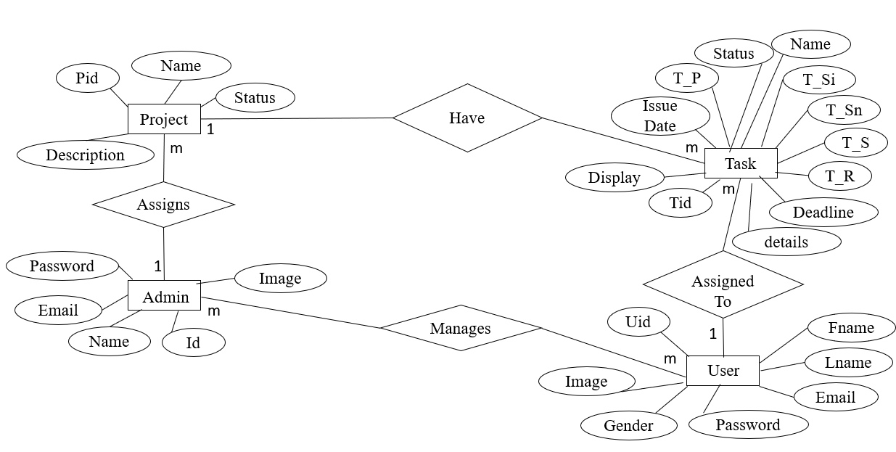ER Diagram
2. Class Diagram

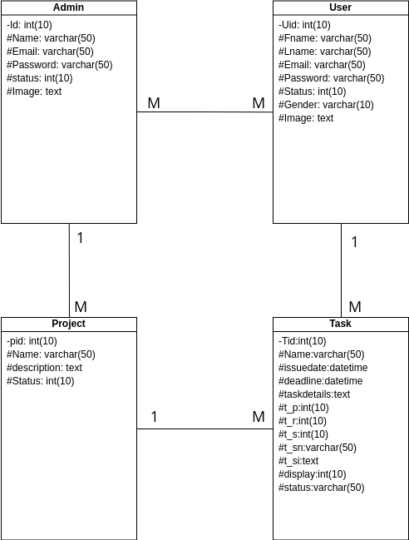

1. Use case Diagram

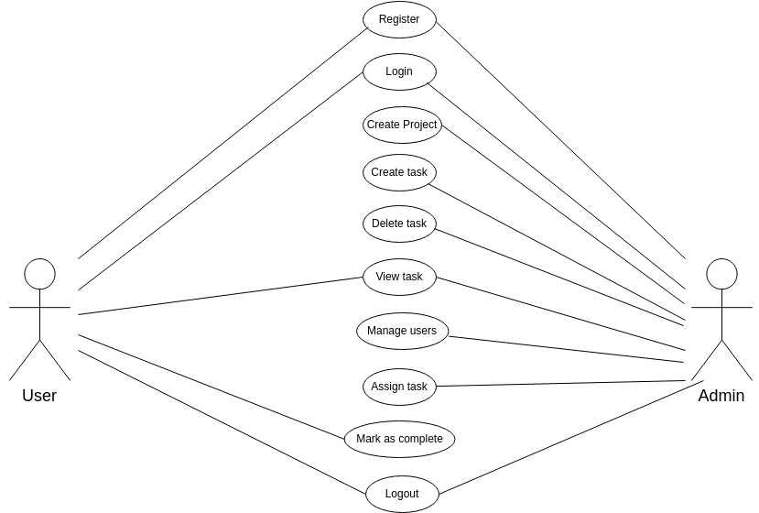

1. Activity Diagram

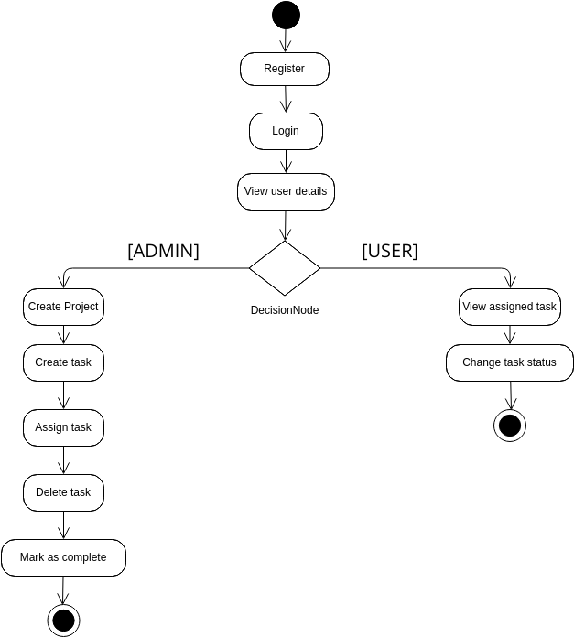

1. Sequence diagram

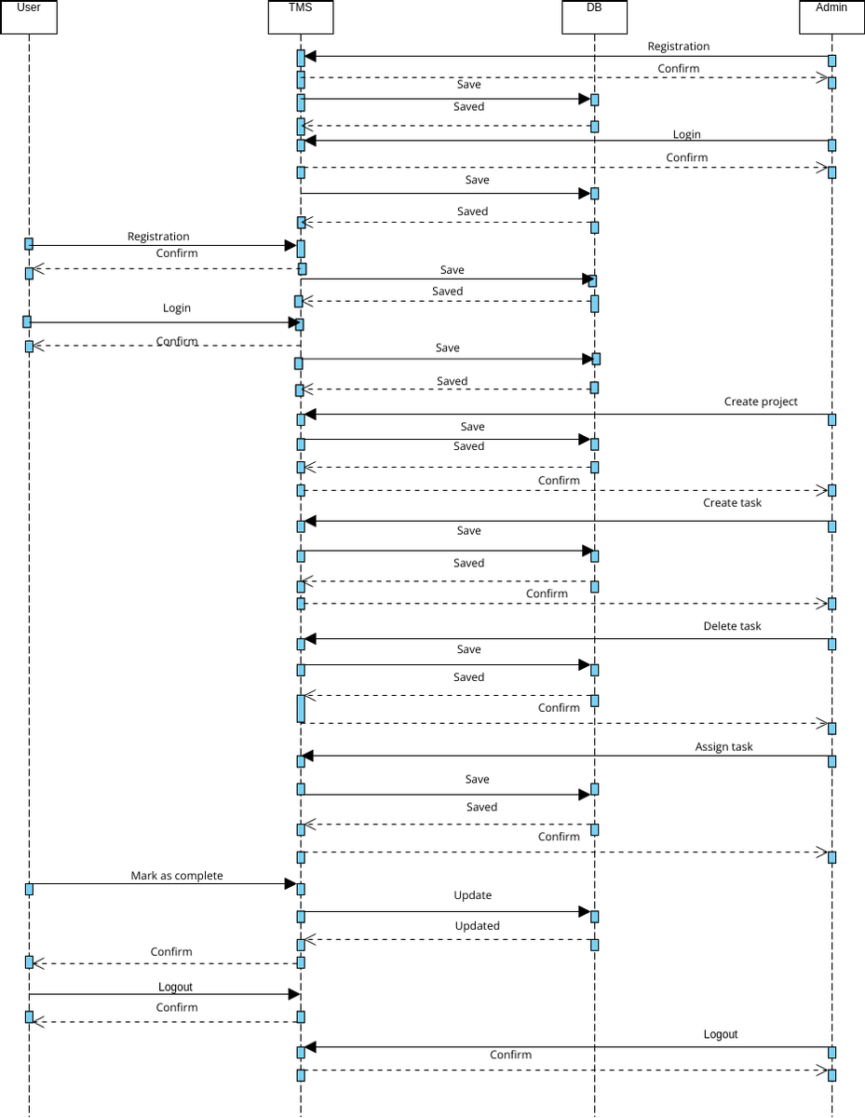

1. Deployment Diagram

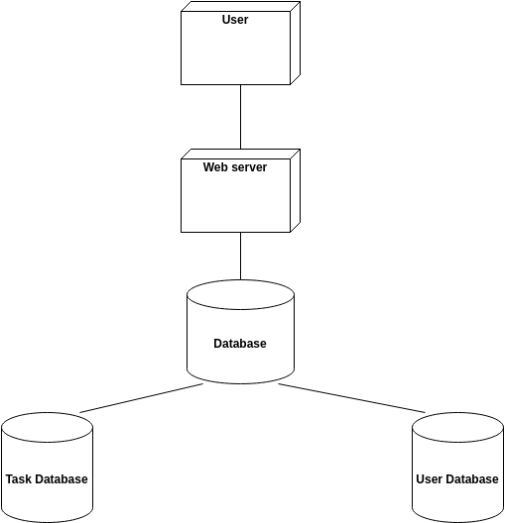

**OUTPUT SCREENS**

1. **Admin Registration**

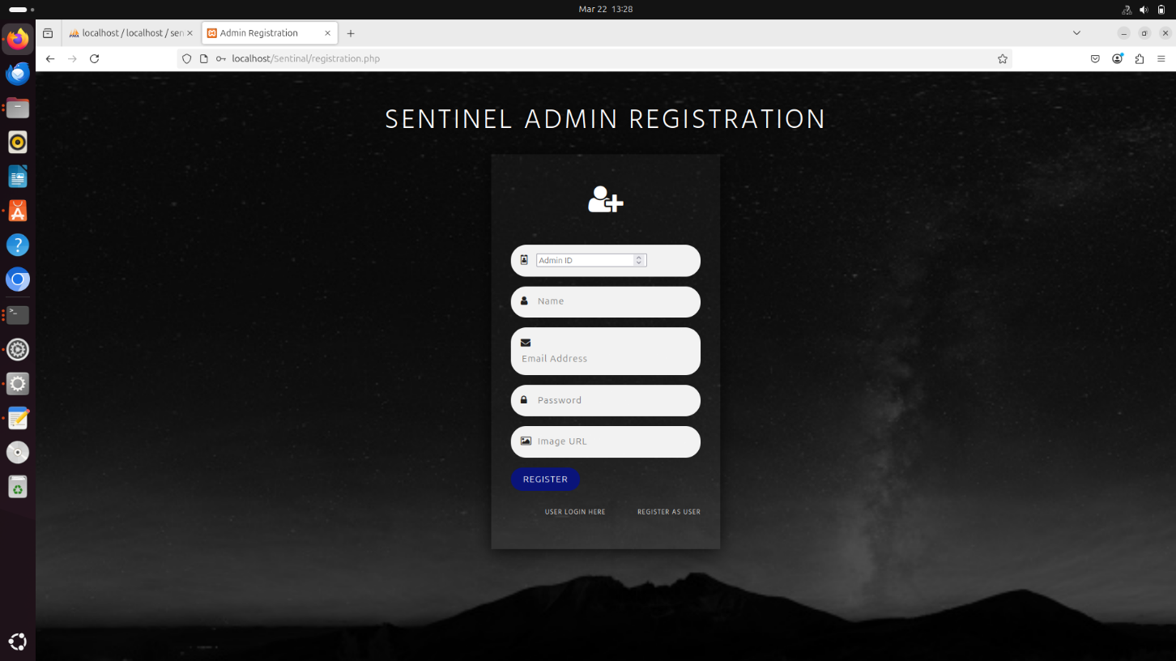

1. **Admin Login**

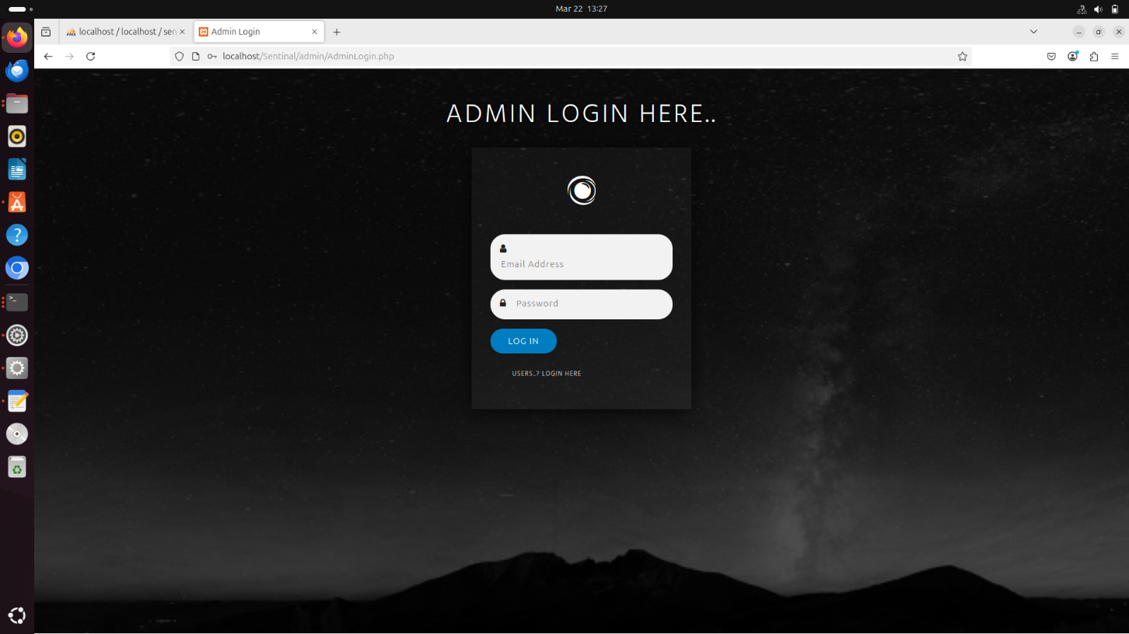

1. **User Registration**

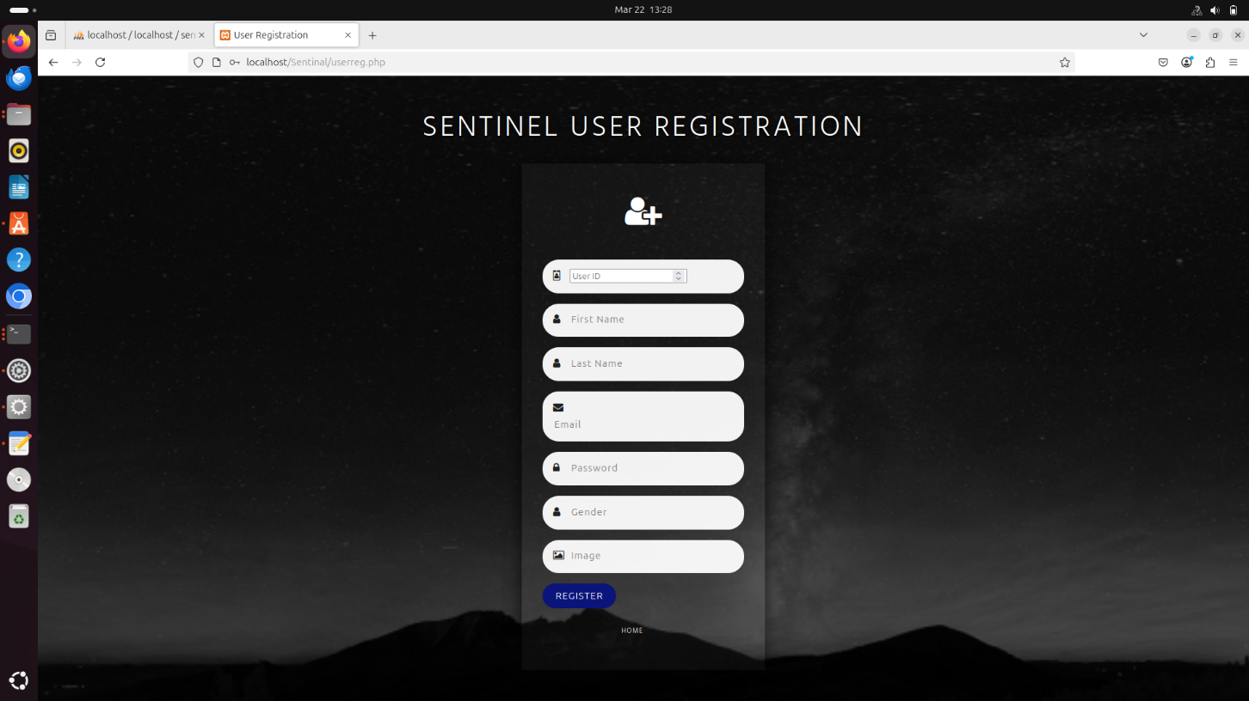

1. **User Login**

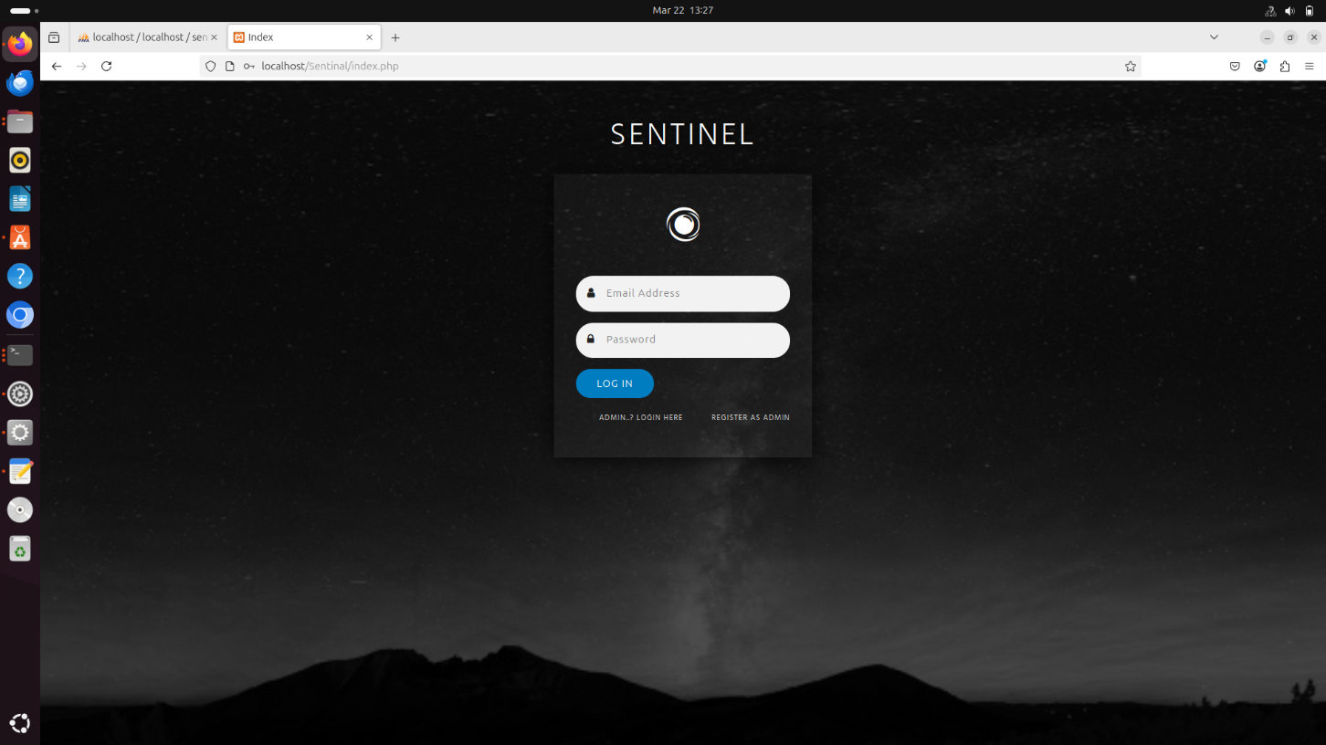

1. **Admin All Users**

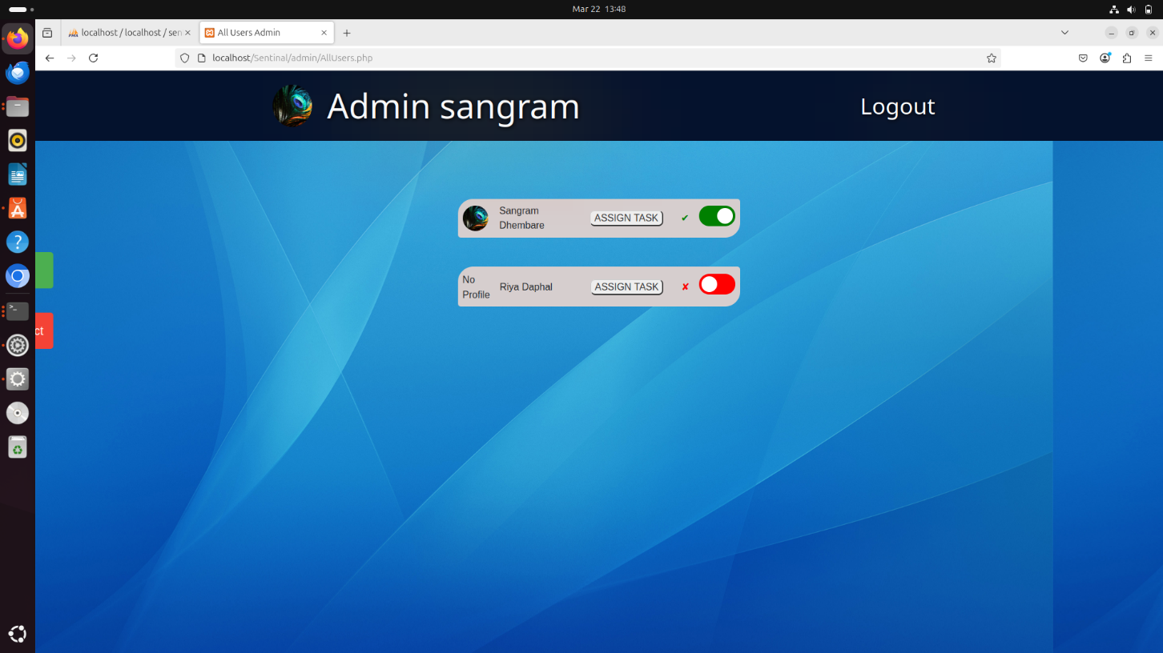

1. **Admin Home Page**

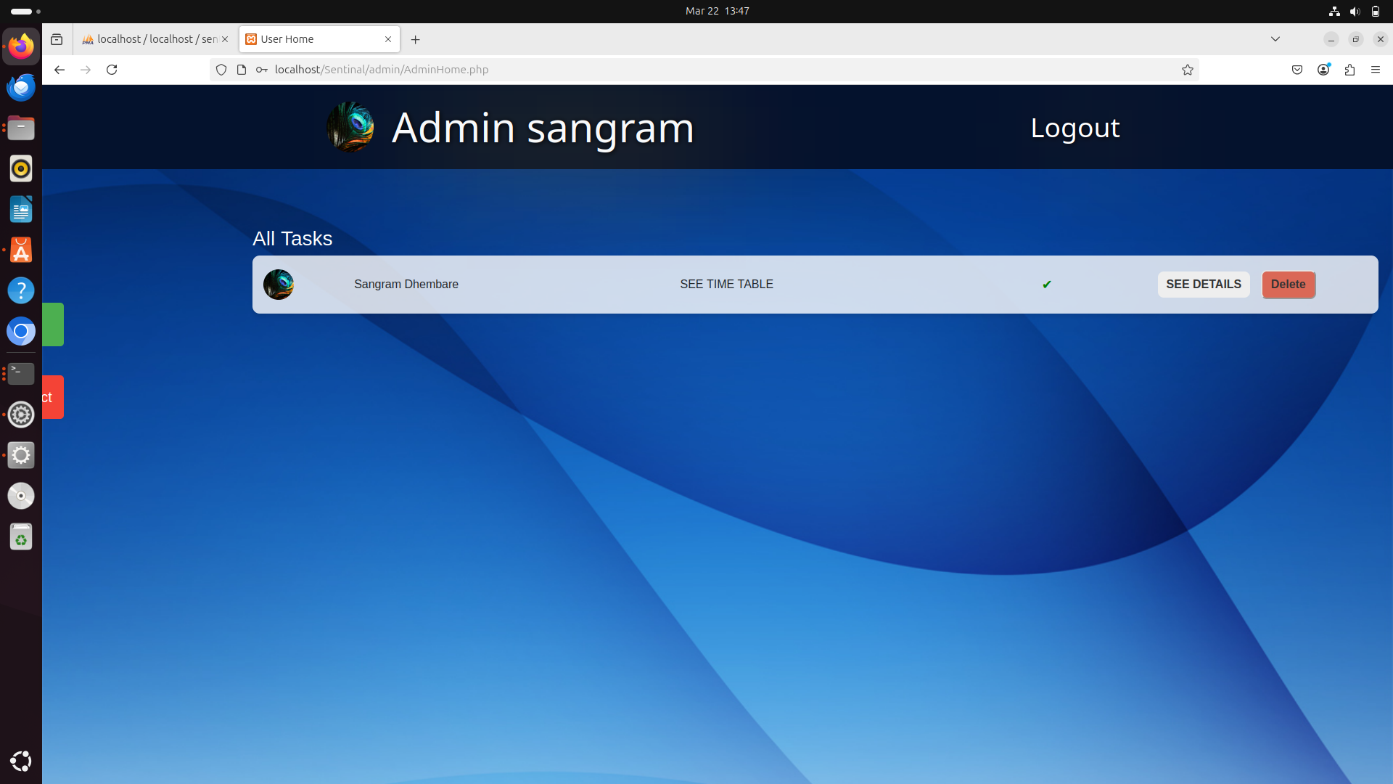

1. **Update User Profile**

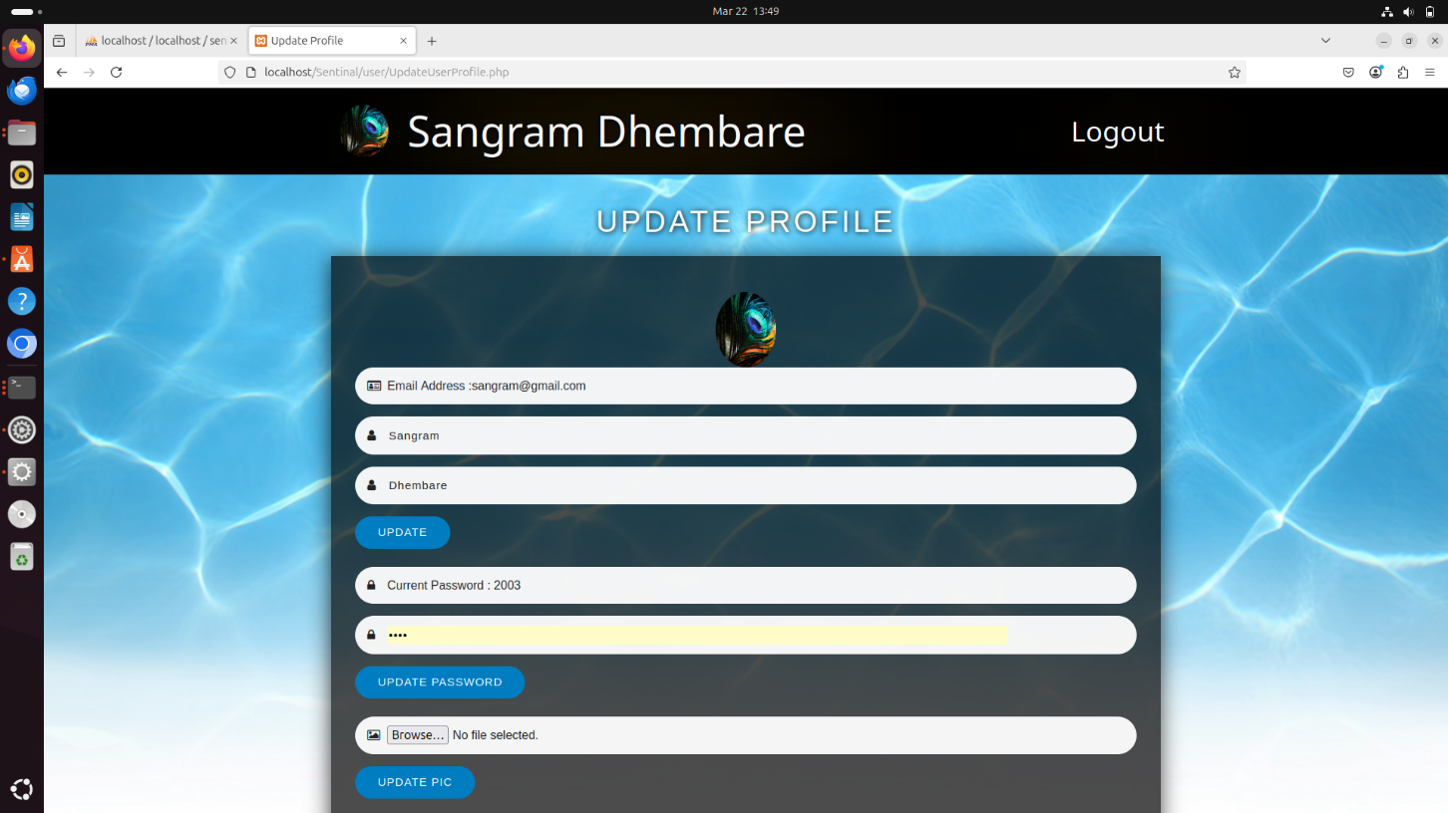

1. **Add New Project**

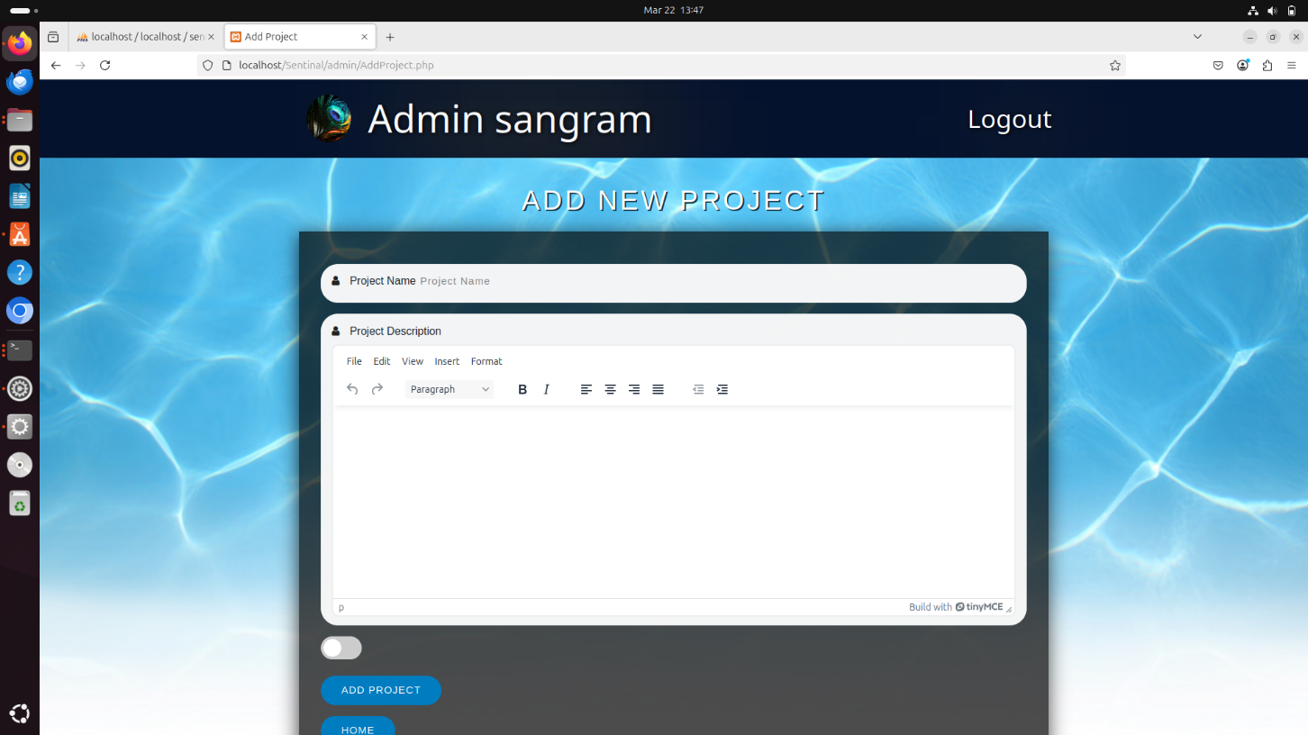

1. **Sent Task**

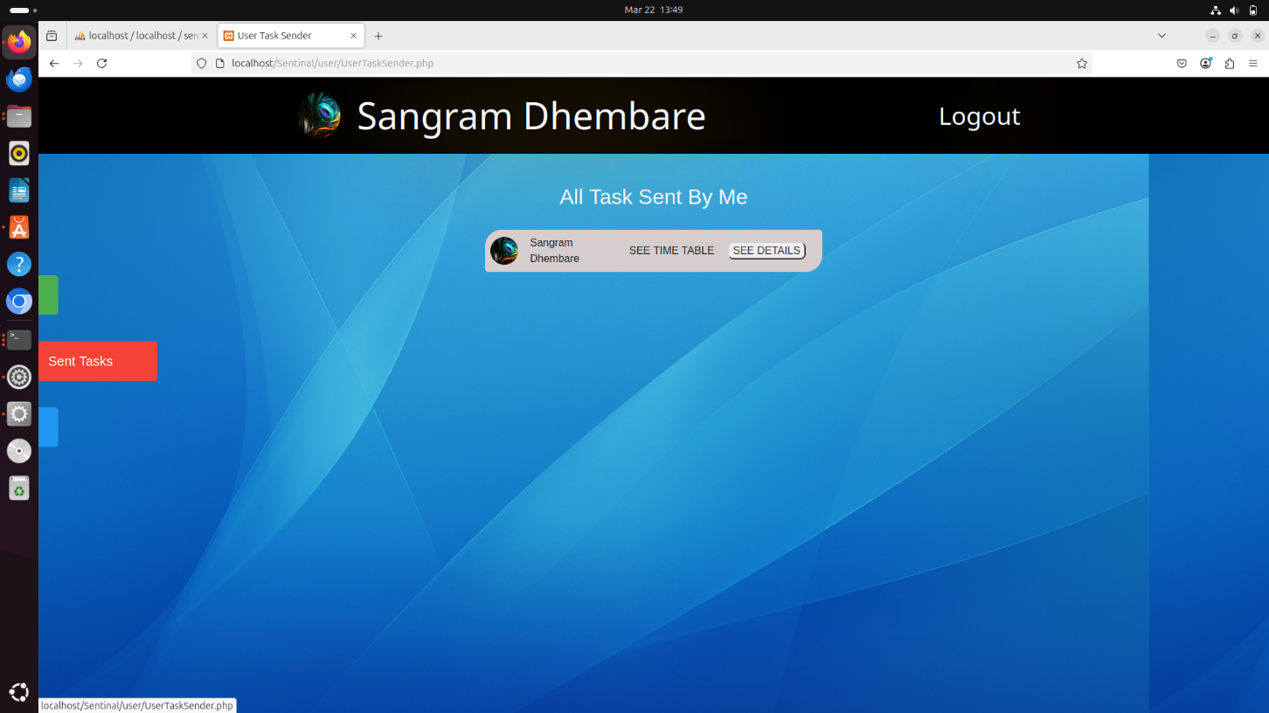

1. **Other User List**

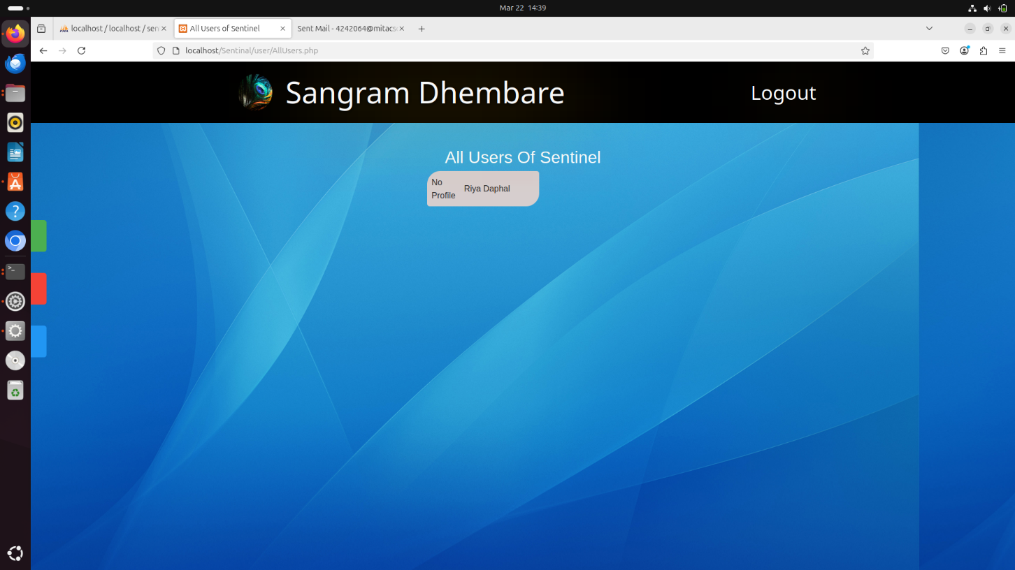

1. **Task Update**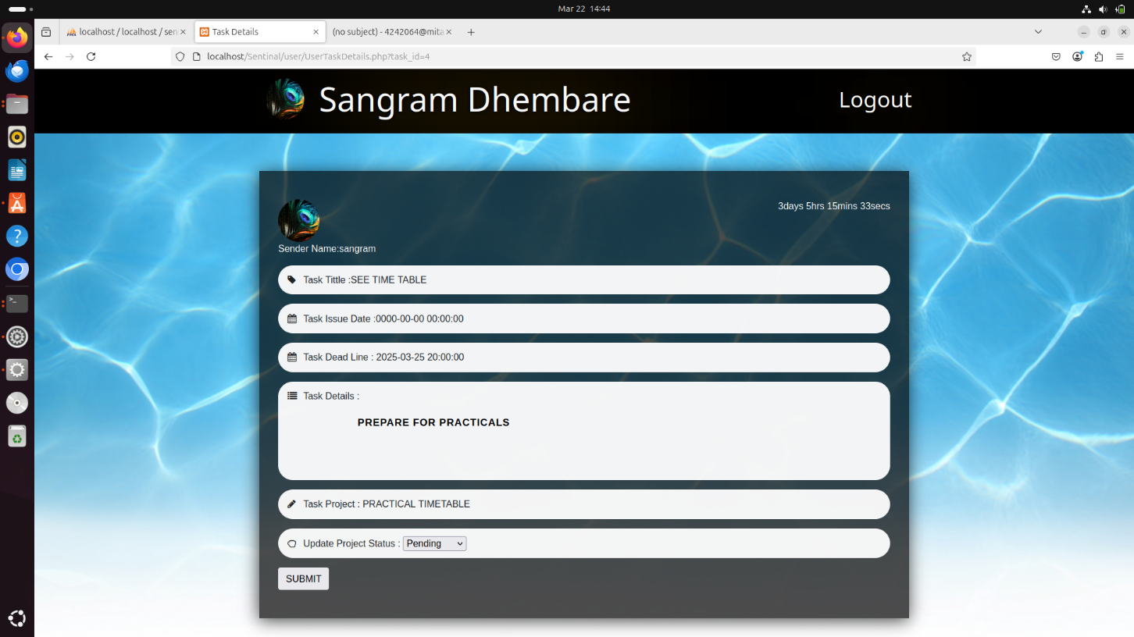

**Future Scope**

* AI Integration: Intelligent task suggestions and priority optimization.
* Mobile Apps: Cross-platform access for convenience.
* Team Collaboration: Advanced features for team management and communication.
* Cloud Storage: Secure and scalable task data storage.
* Customization: Personalized features for different user needs.
* Data Insights: In-depth analytics for productivity trends.

**CONCLUSION**

The sentinel task management system successfully streamlines task planning, tracking, and collaboration. Its user-friendly design and scalable features make it a practical solution for improving productivity and organization.

**BIBLIOGRAPHY**

1. [**https://www.youtube.com/watch?v=2fM6BJXvP6A&list=PLejKBGxF74J6Vm4RB06-3Qzxz1dn5XR0R&index=1**](https://www.youtube.com/watch?v=2fM6BJXvP6A&list=PLejKBGxF74J6Vm4RB06-3Qzxz1dn5XR0R&index=1)

**(Reference video for html, css and mysql)**

1. [**https://www.youtube.com/watch?v=Ff3ug0eqrWI**](https://www.youtube.com/watch?v=Ff3ug0eqrWI)

**(Reference point of project structure)**

1. [**https://www.youtube.com/watch?v=badje_c_A4A**](https://www.youtube.com/watch?v=badje_c_A4A)

**(Tinymce Api Editor integration Guide)**

**4)PHP and MySQL Web Development (5th Edition)**

**Author: Luke Welling, Laura Thomson**

**5)MySQL Crash Course**

**Author: Paul DuBois**

**6)The Unified Modeling Language User Guide (2nd Edition)**

**Author: Martin Fowler**

**7)JavaScript: The Definitive Guide (7th Edition)**

**Author: Eloquent JavaScript (by Marijn Haverbeke)**